The Rosette June, 2022
Zion Evangelical Lutheran Church Volume 51, 6
Two South Hazel Street
Manheim, PA 17545 Phone: (717) 665-5880
E-mail: zmanheim@ptd.net Website: www.zionmanheim.com

Our newly purchased picnic tables have been put to good use by the pre-school classes, small groups, and others in recent days. Good weather has encouraged many of us to be outside! While the tables currently sit outside our main entrance, they will eventually be moved under the trees between the parking lots, ready for the summer lunch program and other general use.

I’ve been thinking about tables. Throughout his ministry, Jesus frequently gathered with others at tables, both as host and as guest. Luke 15:2 notes that Jesus “welcomed sinners and ate with them,” much to the consternation of his critics.

In fact, much of Jesus’ ministry seems to have centered around tables. We might think for example, of that last supper at the table with his disciples, when he took bread and wine in hand and said “do this in remembrance of me.” And after the walk to Emmaus, “When he was at the table with them, he took bread, blessed and broke it, and gave it to them. Then their eyes were opened, and they recognized him.” (Luke 24: 30-31).

For Jesus, tables were places of fellowship and hospitality, reconciliation and revelation. As Lutheran Christians, we believe that “at the table of the Lord Jesus Christ, God nourishes faith, forgives sin, and calls us to be witnesses to the Gospel.” (The Use of the Means of Grace, ELCA) Tables are important!

Picnic tables are simple and ordinary, but I hope our new tables will be places of grace and hospitality as they are used in coming months and years. May God bless these tables and all who will gather there. When meals are shared, may Jesus be present in the breaking of the bread!

Pastor Kate

Rose Festival & Reception, 2022
On Sunday, June 12, Zion Church will once again pay tribute to Henry William Stiegel and his gift of a plot of ground to the Lutheran congregation. The first church, made of logs with a brick floor, was located at the corner of Wolf and East High Streets. Dr. William Hoyt Demmerly and John (JT) Trible, IV, will receive the red rose payment for this year in celebration of the Church’s 250th anniversary.

Please note that our worship on June 12 will be at 10:30 am. The Rev. James Dunlop, presiding bishop of the Lower Susquehanna Synod of the ELCA will be with us to proclaim God’s Word and to help celebrate the occasion.

Please also join us for a reception in the Rose Parlor prior to the morning worship service. Refreshments, sponsored by the Manheim Historical Society, will be served beginning at 9:30am.

Save the Date

A congregational dinner and fellowship event celebrating Zion’s milestone anniversary and 250 years of love overflowing has been scheduled for Sunday, September 18,
at 5:30 pm. This will be a catered meal in the Rose Parlor/Sunday school room, and more details will be announced this summer.

FYI

The new glass roses in the Rose Parlor, as well as the wooden roses in the lobby, were donated to Zion recently by the Manheim Historical Society. (The glass roses are not from Stiegel Glassworks).

Sunday Morning Bible Study

The Sunday morning bible study is taking a break and will resume in the fall. Pastor Kate is interested in suggestions for future studies.

Theologians Under Hitler: Study and Conversation

Beginning Tuesday, June 7, Pastor Kate will lead a study of the role of the church in Germany in the 1930’s and 1940’s. With the help of a documentary DVD, we will be introduced to the thinking of 3 leading German theologians. Their stories serve as case studies to explore a number of important questions: How could the events leading to war and the holocaust happen in the heart of Christian Europe? What went wrong? Could it happen again? How do we recognize evil?

We will meet weekly at 1:30 pm in the Rose Parlor, and the series will (most likely) run for 4 weeks. All are welcome. A zoom option may be possible if there is interest in attending digitally.

Graduation has Arrived!!

Congratulation to Kerri Martin, granddaughter of Bill & Linda Martin, who graduated from Millersville University in May with a Bachelor of Science Degree in Environmental Biology. Well done, Kerri!

Property Concerns

We are still looking for individuals and families to adopt sections of the various garden beds around the building, as well as the mulched area by the cemetery along Wolf St. Keeping up with the weeding is the primary need and concern. We have already heard from some individuals who would be able to weed specific areas. If you are willing to help out, please contact the office at 665-5880. Thanks!

Church Office Hours

Summer hours for the church office are in effect beginning June 1st.
Donna Dieter will be available Monday – Thursday from 8:00am - 1:00 pm.
Please note: the office will be closed on Fridays throughout the summer. Donna’s regular hours will resume once again after Labor Day, beginning September 6th.

Financial Notes:
with joy and thanksgiving for your faithful stewardship.
OFFERINGS | Mo. Total | Budget
April General Fund offering | 17,353 | 17,505
April Capital Campaign offering | 2,130 | -----
May General Fund offering (as of 5/16/22) | 13,755 | 21,882
May Capital Campaign offering (as of 5/16/22) | 2,647 | ——

Capital Campaign Updates
As of this month, we have passed the $100,000 mark for giving to Zion’s capital campaign! We continue to celebrate the faithful stewardship of Zion’s members and all that we have been able to accomplish together.

At the May council meeting, Zion’s council reviewed the progress of the capital campaign, the status of our loan repayments, and the anticipated income in the 2 ½ years remaining in our original 5 year plan.

The council committed to addressing additional property needs and repairs with capital campaign funds going forward. Priority concerns are for sealing and painting the parking lot, and pointing of exterior brick work, especially along Hazel St.
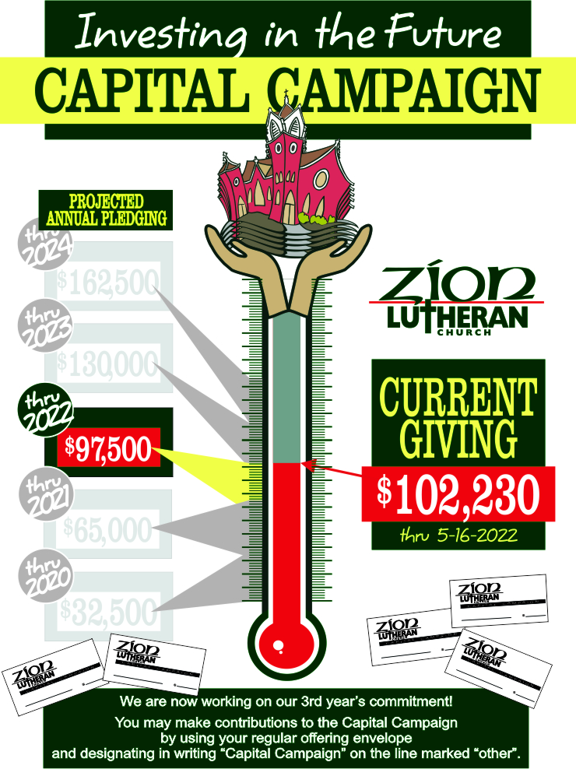
Daughters of Zion

The Daughters of Zion class meets the 3rd Monday of each month at 1:30pm in the Rose Parlor. Our next meeting is scheduled for Monday, June 20th. This class assists in church and community activities where there is a need. They also collect food items for the Manheim Central Food Pantry.

At our May meeting, we had guest speaker, Mike Dieter, who shared his gift of wood carving. He has made birds since the early 80’s and presented a demonstration of his carving skills. He has taught many classes over the years. He shared his techniques and had items on display for us to look at. He was very helpful in answering questions that we had. Class members had a great time and learned a lot of new things. Many thanks to Mike for sharing his craft. We all had a time to socialize after the demonstration and enjoyed goodies provided by Yvonne Kreider.
Our next meeting on June 20, 2022 will be a “Strawberry Social” hosted by Jean Rambler and Dot Longenecker. We will have strawberry shortcake and will play some games and have prizes. Time to just relax and get ready for the first day of summer, which starts the next day, June 21st.

Please remember your Food Pantry items. They are looking for the items listed below for this month. All items are greatly appreciated.

See you in June!! Nadine

Food Pantry Report

During the month of June, the Manheim Central Food Pantry is looking for Spam, canned fruit, especially pineapples, tissues, crackers, baked beans, and canned beets this month.
Please put your donations in the grocery cart outside the church office or drop them in the collection box on the front porch of the food pantry located at 334 W. Gramby St., Manheim. Monetary donations may also be sent to the MC Food Pantry, c/o Salem United Methodist Church, 140 N. Penn St., Manheim, PA 17545.

Preschool News

We did it!! Another year of ZLP in the books. Our teachers and families put a great year together and our students are ready to take that next step!

We had the opportunity to take a field trip to Baron Elementary and practice what it’s like to be in kindergarten. Our Pre-K kids and their families enjoyed graduation ceremonies inside and out due to weather.

What a fun time of year! We will miss these fantastic kiddos over the summer and look forward to our group for next year.

We can’t thank you enough for your support and dedication of the preschool.

Thank you. Katie Mummau
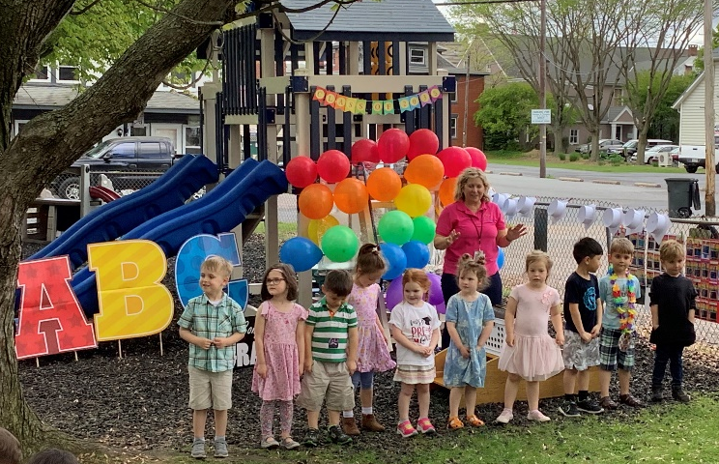
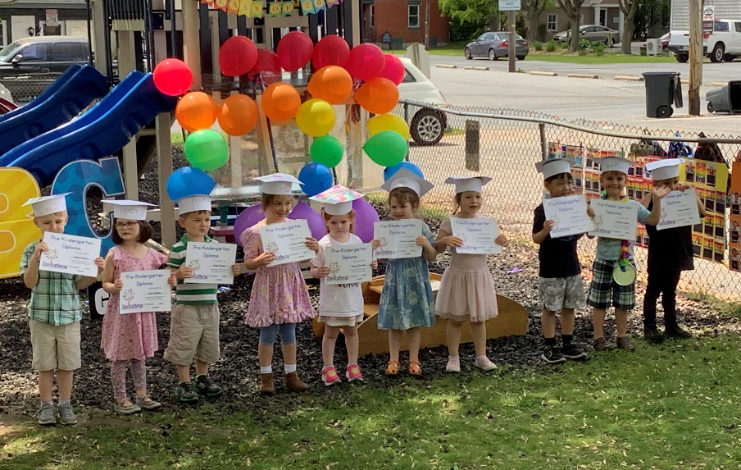

Thank you to all who sent birthday cards to me. Never thought I’d still be around at 82. (We’re glad she is!!)

Judy Long

I want to say “Thank You” to everyone who remembered me on my birthday recently. It really made my day with the number of cards I received.
Erma May

I don’t really know how to say “thank you” enough to all my friends. What a pleasure it was to receive all the cards, flowers, gifts, visits, and phone calls. I didn’t realize how wonderful it would be to celebrate 100 years. A big “THANK YOU” to the choir for their unexpected surprise. I pray for God’s blessings on one and all.
Rubye Barto

The Expanded Prayer List is published at the beginning of each month and is available by e-mail. Printed copies are available at the church for those people who don’t receive e-mails. Please contact Linda Keiffer @ 665-9646 (h) or 742-2149 (c) to add a name to the list and to initiate the prayer chain. She will, in turn, notify the church office of the name and the reason for prayer.

Current Prayer Warriors to Zion’s Prayer Chain include: Rubye Barto, Holly Brosey, Linda Keiffer, Yvonne Kreider, Verna Landry, Judy Long, and Donna Rhodes

Take note: Please have permission from the person whose name you are placing on the list for prayer. The name of the contact person and phone number are also important for updates and further information about the person being prayed for.

June Birthdays

6/1 Cindy Breneman
Jordan Fry
Brandon Moore
6/2 Sandy Quesenberry
Heather Schroll
Fay Varner
6/4 Missy Hoffman 6/16 Brian Miller
Colleen Sprenkle Cale Moore
Dennis Shafnisky Carol Phillips
6/6 Reuben Kauffman 6/21 Dave Lynes
6/8 Kay Hoffer 6/24 Joe Murray
6/11 Holly Brosey 6/26 Glenn Ober
6/13 Quinn Fotiou 6/29 Dan Barthold
Sue Shaw 6/30 Tyler Fotiou
6/14 Mary Welliver

June Anniversaries

6/2 Jon & Beverly Jensen
6/6 Jim & Susan Scales (40 years)
6/8 Kevin & Donna Wilkie
6/12 Kevin & Janet Witman
6/22 Wayne & Elaine Olson
6/27 Bill & Martha Maney

June Readings

June Readings, cont’d
6/25 Psalm 16
Deuteronomy 32:15-27, 39-43
Luke 9:21-27

Third Sunday after Pentecost
6/26 1 Kings 19:15-16, 19-21
Psalm 16
Galatians 5:1, 13-25
Luke 9:51-62

6/27 Psalm 140
Genesis 24:34-41, 50-67
1 John 2:7-11

6/28 Psalm 140
Jeremiah 3:15-18
Ephesians 5:6-20

6/29 Psalm 140
Jeremiah 23:16-22
Matthew 10:16-25

6/30 Psalm 66:1-9
2 Kings 21:1-15
Romans 7:14-25
6/17 Psalm 22:19-28
Isaiah 57:1-13
Galatians 3:15-22

6/18 Psalm 22:19-28
Isaiah 59:1-8
Matthew 9:27-34

Second Sunday after Pentecost
6/19 Isaiah 65:1-9
Psalm 22:19-28
Galatians 3:23-29
Luke 8:26-39

6/20 Psalm 64
Job 18:1-21
1 Corinthian 1:18-31

6/21 Psalm 64
Job 19:1-22
Ephesians 2:11-22

6/22 Psalm 64
Ezekiel 32:1-10
Luke 9:37-43a

6/23 Psalm 16
Leviticus 9:22-10:11
2 Corinthians 13:5-10

6/24 Psalm 16
2 Kings 1:1-16
Galatians 4:8-20

Altar Flowers
June 5 Fay Varner
June 12 None needed due to Rose Festival
June 19 Erma May in memory of George May, Sr.
June 26 This space available. Please call office at 665-5880.

Note: Flowers are $40 per week, and must be paid to the church by the beginning of the month for the flowers you are sponsoring. Thank you.

Bulletin Sponsors
Month of June – This month is available. Please call the office at 665-5880, if interested in sponsoring the bulletins.
Bulletins are - $9.00 per week

Worship Help Schedule

Date | Greeters/Ushers | Lay Readers
6/5 | Joanne Tome | Denny Valins
6/12 (10:30am) | Donna Moore | Sue Shaw
6/19 | Mike & Kathy Connelly | Fay Varner
6/26 | George May | Brian Miller
7/3 | Stan Rohrer | Carol Atherholt
7/10 | Martha Rudisill | Donna Moore
7/17 | Bob & Mary Ann Greiner | Ronda Moore
7/24 | Erma May | Kyle Spohn
7/31 | Doug & Sue Shaw | Mary Welliver

Zion’s Prayers

Please remember Zion’s members as you pray:
Helen Blank Ken Brosey Paul Caplinger
Doug Connelly Karen Connelly Kate Eichelberger
Earl Gernert Barbara Grunenberger Kay Hoffer
Reuben Kauffman Verna Landry Jacquie McKinney
Nadine Mozingo Wayne Olson Donna Rhodes
Nic & Stefan Spohn Phyllis Vogel Utha Webb
Mary Welliver

Please remember our Friends of Zion in your prayers:
Denny Ammerman Ellie Adair Barr Daryl Barry
Delores Barthold Edna Barto Kathy Brosey
Caroline Bill Caye Hana Haatainen Caye
Bill Duncan Sara Echegoyen Terri Elgire
Agatha Eshelman Lewis Ettinger Judy Fiene
Eric Fraunfelter Justin Ken Miller
Bishop Mugabo Steve Rambler Brandy Rhodes
Doris Ritter Jimmy Rodriguez Corene Rohrer
Ted Simpson Frank Smith Paula Stevens
Rachel Toole Thad Toole Joyce Warn
Rebecca Wilkins

Please remember those in Military Service as you pray: Dylan Bowers, Ryan Plowman,
Blake Reber, Ret. Sr. Chief Ed Sexton, and Nicholas Thomas

